**IS 456 IT Database Systems Management**

**Programming Exercise 2**

4/13/2021 Developed by Farzin Bahadori

School of Technology & Computing @ City University of Seattle (CityU)

Using Chinook Database: (**Database is available in GitHub repository under db folder)**

Task 1: Using the Command prompt, create a backup file as a sql text-file, for the albums table, name it as albums.sql. [Use Dump Command]. take a screenshot and submit it.

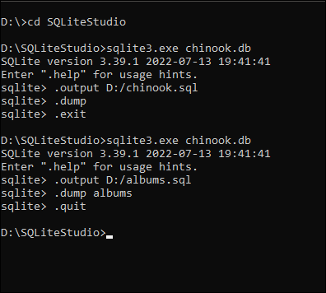

------------------------------------------------------------------------------------

Task 2:

-- Write a SELECT statement that will return the records, and titles columns from the albums table.

-- Filter the results to include only the customers from the country Brazil.

-- Execute the written statement.

----------------------------------------------------------------------------------------

Task 3:

-- Write a SELECT statement that will return First and last names, company, address, phone and email address ofcustomers from the Customers table.

-- Filter the results to include only customers from the countries Canada and USA.

--

-- Execute the written statement.